Student Bike Helmet Pledge
GMSD

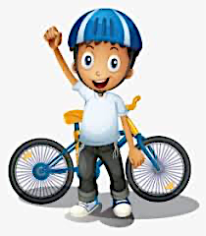

Bike helmets are an essential tool that is needed to ride a bike safely, no matter where you’re riding. The GMSD Bike Safety & Education Program values student safety and requires all riders to wear a helmet. We are requesting that your child brings his/her own helmet to school for the weeks that their PE classes will be participating in these lessons (PE teachers will send home a letter with dates).

For Personal hygiene reasons, we will not be providing helmets that students would have to share with others.

I, ___________________________, value bike safety and pledge to wear a helmet no matter where I ride, whether it’s at school or home. I want to be a positive role model and show others the importance of being bike safe and smart!

*Check out our Bike Helmet Safety Page: https://www.thephysedexpress.com/bike-helmets.html

Student’s Name: ______________________________ Date: __________________________

Parent’s Name: _______________________________ Date: __________________________

Parent’s Signature: ______________________________________________________________

