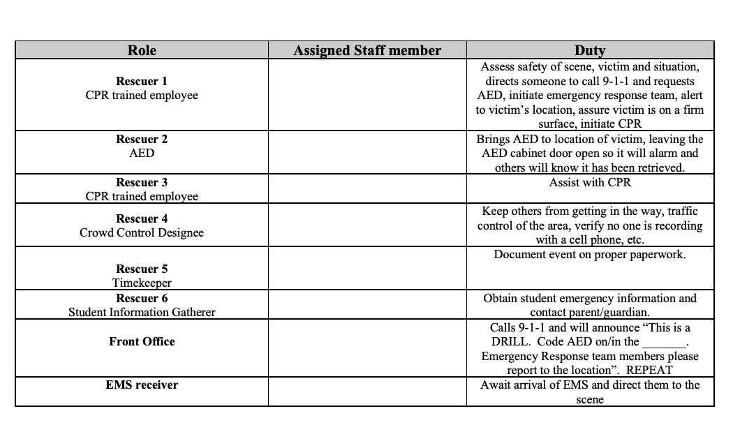
*Email your Emergency Response Team roster to CSH when finalized. Every school is required, under TN law, to have at least one CPR/AED drill each school year. CSH will need to be present for this drill.

