Health Info

Entering Immunizations:
- Students> Student Profile> Health> Vaccinations> Entry
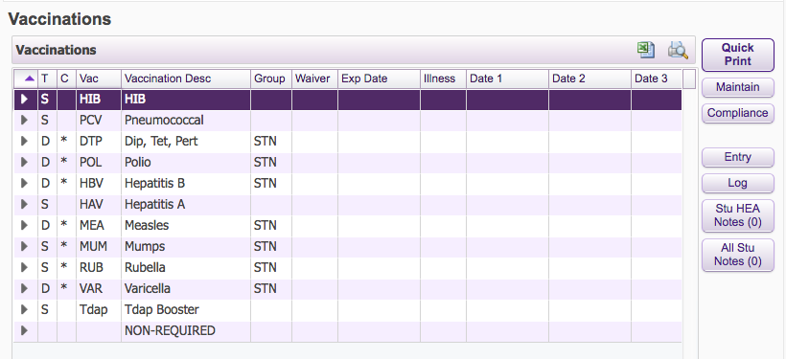

- Enter Date, Vaccine (click on the word Vaccine to pull up a list to select from)> Add Dose> Save to add another OR Save and Back to finish
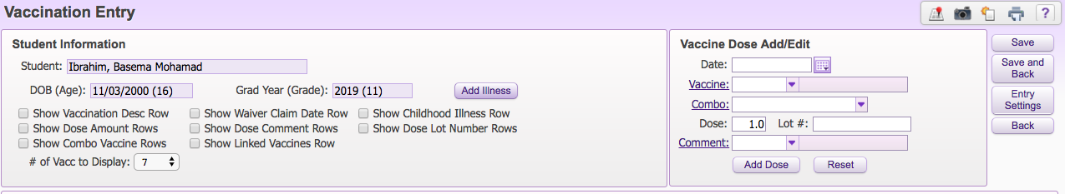

Entering Screenings:
- Students> Student Profile> Health> Physical> Add
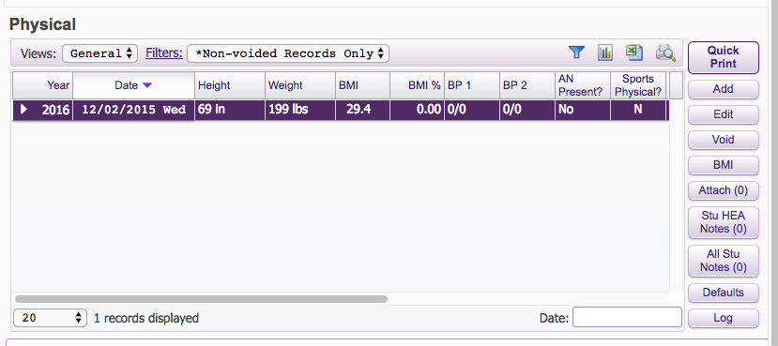

- Enter Physical Screening Information and Save
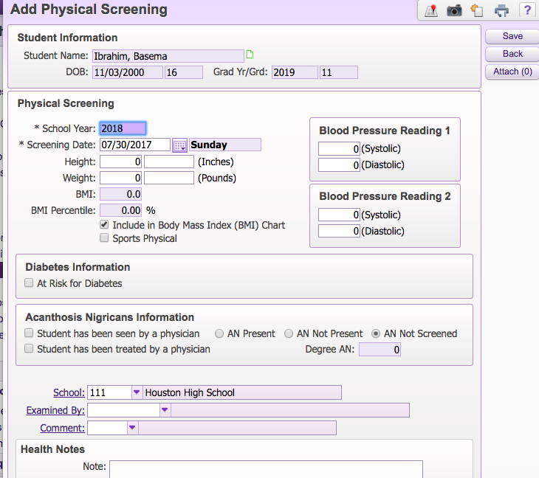

- Students> Student Profile> Health> Hearing> Add
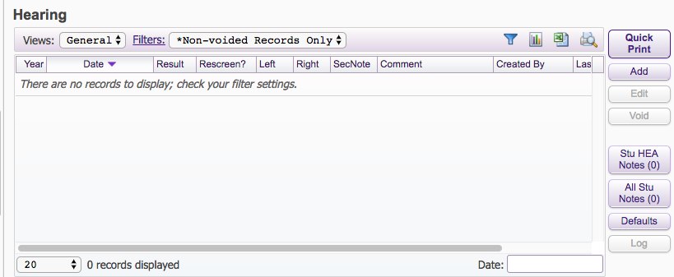

- Enter Hearing Screening Information> Save
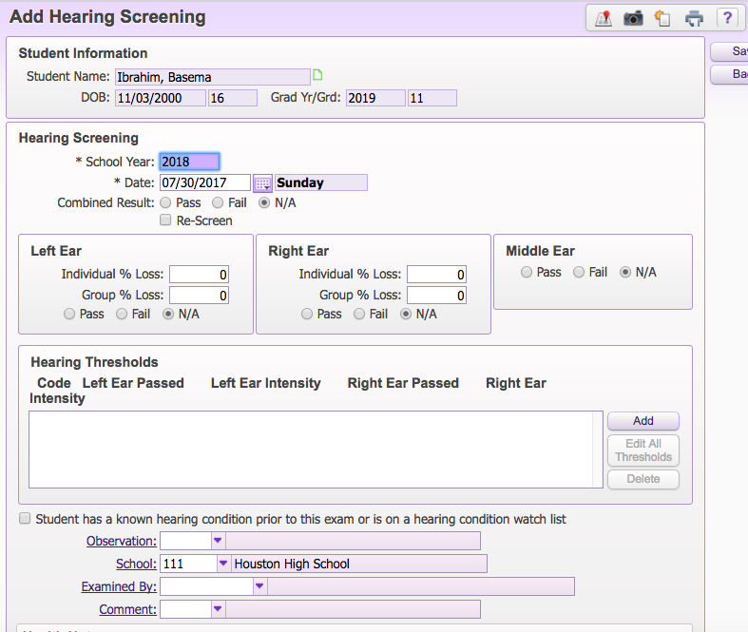

- Students> Student Profile> Health> Vision> Add
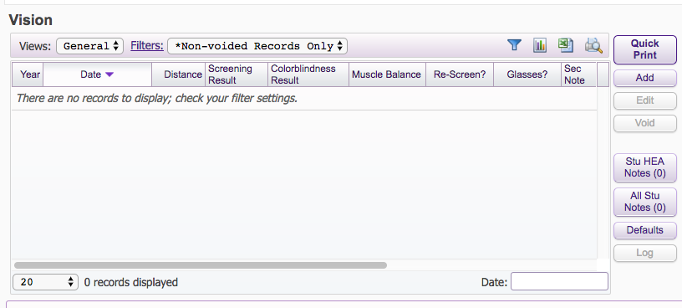

- Enter Vision Screening Information and Save
