2022-2023
Healthy School Teams
Team Manual
Department of Coordinated School Health
Andrew Martin
School Health Supervisor
Andrew.martin@gmsdk12.org

INDEX

Information | Description | Pages
Index | Quickly find information in HST Packet | 1-2
Step 1: Gather Your Team | Overview, getting ready to start, link to tips, 3-minute survey link, | 3
Step 1 : Continued.. | Building and leading successful school health teams | 4-5
Step 2: Assess & Track Progress | Visit AFHK website, create log-in (use-link). Familiarize self with School Health Index. | 6-7
Step 3: Create & Implement Action Plan | Learn how to complete a successful Action Plan | 7-9
Step 4: Find Activities | Use links & resources provided to find activities. Create own initiatives | 9-10
Step 5: Engage Families & Community | Use links & Resources to connect to community. Create own initiatives | 10-11
Step 6: Celebrate Success | Share your success with CSH, GMSD TV, CSH Social Media Pages; Revisit SHI to track results | 12-13
General Information | Links to AFHK, TN Dept of CSH, and Social Media Pages for GMSD CSH | 14
What is a HST? | What it is, What a team looks like, how to recruit, meeting frequency. | 15
Resources | Links that can be shard with the team | 16
Due Dates | Dates that SHI, Team meetings, Activity Trackers, In-kind forms, HST List, CPR List, Team evaluation are all due | 17
CSH Activity Tracker Form | Actual form to use and complete; Email completed copies to me by due dates. | 18
CSH Evaluation Data | Form to be completed and emailed back to me by due dates | 19
Action For Healthy Kids Sign-up Steps | Steps to sign-up, locate school, join school, and complete SHI (Only 1 person needs to complete SHI). | 20-23
Healthy School Team Meeting Agenda | Form to complete for each meeting and email to me by due date | 24-25
Healthy School Team List | Add the members of your HST and email to me by due date | 26
CPR Certification & In-Kind Forms | Two separate docs that will be sent to school and returned to me by due date | Attached as separate documents
Step 1: Gather Your Team

Overview
School health teams come in a variety of shapes, sizes, and names (such as school health councils or wellness committees). But they all have a common goal: to rally forces to make schools healthier places for students. Research shows that schools with a wellness team that meets at least once per year have more students at a healthy weight. And having an active wellness team is associated with more healthy nutrition habits, such as students eating fewer sugary foods.

Ready to start one?
We recommend your school health team have between three and ten members, representative of all areas of your school. Together, you’ll identify primary health concerns, lead projects that promote healthy habits, raise funds, celebrate successful health initiatives, and develop resources to help others replicate your efforts.
Building representative school health teams helps to ensure your team is supporting the Whole Child. Think outside the box – when looking at your school health team or committee consider using the Whole School, Whole Community, Whole Child (WSCC) model as your template. Check out this tip sheet for building representative school health teams for ideas on how to expand upon yours.
Before getting started, see where you might want to focus your attention this year by taking the 3-minute School Health Survey.

Building and Leading Successful School Health Teams
- Determine if you can expand on an existing wellness-oriented group or develop a plan to start your own. See if health and wellness can be added to an existing group, such as the PTA/PTO or school improvement team. If there isn’t an existing health team, start your own. Identify more champions to join you, and build on their energy, passion and expertise.
- Develop an “elevator pitch.” In two minutes (or two sentences) or less, be able to describe why you want to create a health team, what types of activities the team will undertake, and what kind of time commitment will be necessary.
- Get the principal’s approval. A supportive principal or assistant principal is essential to your efforts. A principal who participates on the team is ideal.
- Invite school staff, parents, students and community members to join the team. Your team should be creative, committed, passionate, and determined to face challenges head on. The optimal team consists of at least five individuals, including a parent and a school administrator. Inspire them to participate by making the case for school wellness and creating a sense of urgency about the state of children’s health and its link to student achievement. Use local statistics, personal stories and examples from your own school to make your case.
  - Recruit stakeholders who represent the diversity of your community and have a deep understanding of the culture, norms and dynamics of your community.
  - Remember that not everyone needs to be a leader — supporters are just as important to your team’s success.
  - Invite student input and participation. Consider creating more than one student health team member position to have consistent student representation.
- Develop a vision. At first your meeting, have your team write a vision statement that defines what your school will look like if you achieve all of your goals. From there, create a team charter – a document that outlines your goals, project ideas and details for how to begin implementing. Cast the net wide and brainstorm a running list of ideas. As you begin to assess your school (step 2 of Game On), you can then use those results to refine your list and identify priorities.
  - Sample: “ABC Elementary students will learn how to make healthy choices, be physically active and nurture their social emotional health throughout the school day so they are better prepared to learn and begin developing skills and behaviors for a happy, healthy life.”
- Understand your school wellness policy. Take time to review the existing school wellness policy to familiarize your team with requirements and goals. Read this case study to learn how Game On can be used to implement district wellness policies.
- Conduct successful meetings. Use our Guide to Successful School Health Team Meetings to set up meetings in a way that best supports your team. Meet at least four times per school year but aim for a frequency that fully supports your project or plans.

Step 2: Assess & Track Progress
Your team is assembled! Now it’s time to examine your school environment. A wellness assessment is well worth your time and effort and may cover several aspects of the school environment: health education, nutrition, physical activity, competitive foods and beverages, family and community involvement, staff wellness, healthy and safe school environments, and health services.
See where your school succeeds or has room for improvement by using the School Health Index. Visit the AFHK School Portal to access our online School Health Index.

When you conduct a wellness assessment, you enable your team to:
- Develop key relationships with staff.
- Determine your school’s strengths and weaknesses.
- Define goals that suit your school’s need.
- Justify your desire to make changes.
- Document starting points in order to show progress over time.
We offer schools an abbreviated online version of the CDC’s School Health Index (SHI). The SHI is an assessment tool that helps you understand which school health best practices your school has/does not have in place that support healthy students and prepare them to learn. The SHI aligns with the Whole School, Whole Community, Whole Child model to help your school get a comprehensive look at school and student health.
Our SHI includes key questions on various school health topics from the CDC’s version of the School Health Index to provide your school with a shorter, easy-to-complete assessment. Once completed, we’ll provide you with an auto-generated report that summarizes your responses and identifies areas for growth. Focus your school health efforts on these improvement opportunities to ensure you’re providing a learning environment that supports students who are healthy, active and ready to learn.
Your entire school health team can complete the assessment collaboratively online via AFHK’s School Portal.

School Health Index Resources
- School Health Index FAQs
- School Health Index Questions (Elementary School) (questions only | questions and detailed instructions)
- School Health Index Questions (Middle/High School) (questions only | questions and detailed instructions)
- Instructions for using the Action for Healthy Kids School Health Index
Learn about ways to engage students in completing the School Health Index.

Step 3: Create & Implement an Action Plan
Developing a clear action plan is critical to the success of a school health initiative. In addition to serving as a road map, creating a plan provides many benefits, such as:
- Team camaraderie – The process of developing an action plan together will make the team feel more invested.
- Group brainstorming – Each team member brings different skills to the table; action plans will be clearer and more inclusive when everyone plays a role in their development.
- Clear communication – Everyone will understand project goals, what he/she is expected to do, and what the timeline is for accomplishing those tasks. This reduces confusion and potential conflicts.
- A timeline – Written timelines help keep everyone on the same page and keep tasks moving forward.
After you’ve assessed your school health environment using the School Health Index in Step 2, you will receive a report that summarizes your school’s results. This report showcases an overall score that highlights what percentage of health-promoting practices your school has in place as well as “Opportunities for Growth.”
To develop your action plan, review the “Opportunities for Growth” on your School Health Index report. Identify what is feasible for your school to accomplish during the school year, and pick three to five priorities. These activities will serve as the foundation for your school action plan.
Log in to our School Portal to review your School Health Index report.

Steps to Develop Your Action Plan
- Review your School Health Index Results. After you complete the SHI, your school receives a report that summarizes opportunities for growth. Identify the opportunities for growth that are feasible for your school to accomplish this year, and select three to five priorities on which to focus your school health efforts.
- Translate your SHI Results into an action plan. Your action plan can be as simple or as elaborate as you’d like. For a simple version, print your School Health Index report, highlight your priorities and use that as your action plan. Next, outline activities, dates, resources, etc. for each priority. Regardless of the type of action plan you use, bring a copy of it to each School Health Team meeting to review progress.
- Select and search for activity ideas. Game On has resources to support each topic area on the School Health Index. Once you have identified your top priorities for the year, visit Step 4 to find Game On Activities that align with your priorities. Each Game On activity provides ideas, tips and resources to support you in successfully implementing the activity. Contact us at ContactUs@actionforhealthykids.org if you need additional support.
- Apply for grants! Find funding to help you implement your action plan.
- Put the plan into action. Use the action plan to track your progress against your health priorities. Revisit the action plan throughout the year to update objectives and check off completed actions.
Consider including students in creating and implementing your action plan. Assign tasks to each student and have them weigh in on what actions should be included. This will help students understand their role in creating a healthier school environment if they see how they fit in the action plan and other activities your team undertakes. Be sure to celebrate your action items when you achieve them to help keep members engaged!

Step 4: Find Activities
It’s time for some fun! Once you’ve built your school health team and used the SHI to assess the school health environment, choose some activities to help achieve your health and wellness goals. We’ve got over 100 activities on a wide variety of topics, so search the library to see what best suits your school’s needs.
Before you get started, here are some helpful tips:
- Test drive an activity at any time. Or, if your school health team is just starting out, we recommend starting Game On from the beginning and then using the activities to tackle your school’s specific areas for improvement.
- Schools that receive grants from AFHK are encouraged to use Game On activities to help implement their grants.
- Physical activity activities include tips and guidelines for making activities inclusive of students with special needs.
Visit Activity Library
Did You Know? Children with special needs are about twice as likely as other children to be overweight or obese, often due to the related greater likelihood of being sedentary. Some conditions, such as cerebral palsy, increase difficulty in eating, which leads to being underweight. However, the general trend of obesity in children with special needs is much greater. Learn how to ensure your health initiatives are inclusive of all children.

Step 5: Engage Families & Communities
Get others on your side! In order for any program to be successful, it is vital to engage key groups of adults, such as school staff, parents, schools board members, community organizations and local business owners, who want to support your vision to create a healthier school. These partnerships can not only improve student learning by promoting consistent messages about healthy behaviors, but they can also provide access to additional resources and volunteers.
- Empower and engage families with parent tools and resources. Find information about how school systems work and the most effective ways to advocate for change, along with ideas for creating a healthier school food and physical activity culture.
  - The Centers for Disease Control and Prevention (CDC) has also developed a set of resources called Parents for Healthy Schools to help schools and school groups (e.g., parent teacher associations (PTA), parent teacher organizations (PTO), school wellness committees) engage parents to create healthy school environments.
- Involve community organizations to donate healthy food, offer trainings, host a trip to a local garden, and more. Consider reaching out to businesses, health departments, parks and recreation departments, universities, local foundations, restaurants, and faith-based organizations.
- Recruit community volunteers to support your programming and events. Volunteers can offer new perspectives and make a lasting impact and contribution through their knowledge base and support. They also can provide an extra helping hand or a needed, valuable skill set. Brainstorm ways to engage individuals, organizations or businesses who are passionate about healthy kids to help with your program needs or to offer their expertise.
- Host an Every Kid Healthy™ Week event for students, families and the larger community. Every Kid Healthy Week is an annual observance created to celebrate school health and wellness achievements. However, any time is a good time to plan a healthy event at your school. Find great resources and ideas.
To develop successful and meaningful partnerships, communicate expectations up front. People in supporting roles are just as important to your success as leaders, so remember to provide a welcoming climate to families and outside organizations, and always check in with your principal to ensure you’re on the same page.

Step 6: Celebrate Success
The last step in the Game On process is to celebrate the success you’ve had in making health-promoting changes to your school environment to ensure students are healthy and ready to learn. Recognizing your accomplishments can help your school maintain momentum and support for school and student health. Celebrations also give you the opportunity to reinforce the importance of your work, recognize the achievements of students and adults, thank staff and volunteers who contributed to your efforts, and take pride as a school and a community in what you accomplished.

Identify Wins
Revisit your School Health Index results and take a moment to update your assessment. Where have you improved? Work with your School Health Team to create a plan for celebrating and sharing these improvements. Celebrate wins, no matter how big or small! Incremental improvements support long-term, sustainable programming. To share your success, consider:
- Meeting with school and district administrators to highlight your work (and advocate for continued support);
- Sharing on your school’s social media and website, in newsletters and at school events;
- Contacting local media to do a story;
- Speaking at an open school board or other community meeting on the importance of physical activity and nutrition and the actions your school has successfully taken;
- Recognizing students, staff, families and community members that contributed to your success;
- Hosting an event such as a community breakfast, student assembly or Every Kid Healthy Week event to have fun, recognize contributors and reinforce healthy messages;
- Sharing your school’s success with Action for Healthy Kids to inspire other schools to improve their environment to ensure kids are healthy and ready to learn.

Plan for Next Year
As you celebrate wins, spend some time with your team reflecting on challenges and additional opportunities for improve school and student health. Review the Opportunities for Growth section of your School Health Index report to identify 3-5 priorities for next year. Game On is a cyclical process and each year, we encourage you to work through each step to ensure you have the people, tools, resources and programming to make your school the healthiest place it can be.

GENERAL INFORMATION
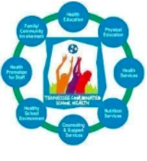
Action for Healthy Kids Log-in Page

https://afhkschoolportal.force.com/AFHK_Communities_Login

CSH Social Media Pages (Share Your Success)

Facebook: https://www.facebook.com/gmsdhpelw

Twitter:
https://twitter.com/gmsdcsh

TN Coordinated School Health Website
https://www.tn.gov/education/health-and-safety/coordinated-school-health.html

What is a Healthy School Team (HST)?

A HST is a group of steak-holders in each school that represents an area of Coordinated School Health and works collaboratively to define yearly health goals for their school/students, and develops and carries out action items to address these goals.

The following roles/persons are required to ensure a well-rounded HST:
• School Administrator
• Physical Education Teacher
• Plant Manager
• School Resource Officer
• School Counselor
• Cafeteria Manager
• Classroom Teacher
• Parent
• Student
• School Nurse
• Representative from School Emergency Response Team (SERT)
• Health Teacher (if applicable)

How do I recruit HST Members?

Start with your administration! They will be a huge help in reaching out to people. Contact your PTA President and the Student Council Sponsor. Ask your admin if you can send a blanket email to your building staff and make sure each member knows how valuable their time and onion is on school health issues.

• Make sure those who are on your team, know they are on your team; don’t assume that because they volunteered, they will automatically show up to your first meeting.

How Frequently should a HST meet?

In order for HSTs to be most effective, it’s important that they meet at least 4 times per year. It’s strongly encouraged that the first meeting be during the two weeks of in-service, if possible, so that school goals can be developed before the busy time of “Back to School” begins. Send reminders; set calendar dates; make an announcement over your intercom: whatever you need to do to get your whole team there. Meetings will be more effective, and goals will be more easily accomplished when your whole team is in attendance.

*Only one meeting may be conducted via email as a means to check in on the progress of each team member.

RESOURCES

You may share any resources with the team that you find useful

- Eat Right.org
  - https://www.eatright.org/
- Alliance for a Healthier Generation
  - https://www.healthiergeneration.org/
- Fuel Up to Play 60 *grant opportunities*
  - https://www.fueluptoplay60.com/
- TN Coordinated School Health
  - https://www.tn.gov/education/health-and-safety/coordinated-school-health.html
- The Governor’s Foundation for Health & Wellness
  - https://www.tn.gov/education/health-and-safety/coordinated-school-health.html
- Action for Healthy Kids
  - http://www.actionforhealthykids.org/index.php

My Physical Education Website for GMSD has TONS of resources and over 180 pages filled with valuable content!

Main Site:
https://www.thephysedexpress.com/

HST Page of my website:
https://www.thephysedexpress.com/healthy-school-teams.html

AFHK Page of my website:
https://www.thephysedexpress.com/afhk-school-health-index.html

Healthy Schools Environment Toolkit:
https://www.thephysedexpress.com/healthy-schools-environment.html

CSH Mini-Grant Application:
https://www.thephysedexpress.com/school-health-grants.html

DUE DATES

- Health School Teams List, DUE = September 16th

- CPR Certifies List, DUE = September 16th

- Action For Health Kids School Health Index, DUE = October 7th

- Meeting 1 Notes, DUE = October 7th

- Activity Tracker, Semester 1, DUE = January 6th

- Team Evaluation, Semester 1, DUE = January 6th

- Meeting 2 Notes, DUE = March 10th

- Meeting 3 Notes, DUE = May 12th

- Activity tracker, Semester 2, DUE = May 12th

10.)Team Evaluation, Semester 2, DUE = May 12th

11.)In-Kind Report, DUE = May 12th

Coordinated School Health Activity Tracker
2020-2021 School Year

School Name:

Semester:

*Please include any upcoming partnerships, activities and events if they are already scheduled and/or in progress of planning.

DUE TO ANDREW MARTIN ON JAN. 6TH & MAY 12TH (Andrew.martin@gmsdk12.org)
Health Education: | Physical Education /Physical Activity:
Healthy School Environment: | Nutrition:
Health Services: | Family and Community Engagement:
Mental Health & School Counseling: | Health Promotion for Staff:

School Name: _______________________________ Grade Levels _________

Healthy School Team Leader ______________________________
Semester 1 CSH Evaluation Data Semester 2
No. hours: ________ | Total amt. of Staff Development time spent on health-related issues (CPR, first aid, suicide prevention, Behavioral S-teams, asthma, diabetes, bloodborne...) | No. hours: ________
No. participants: ________ | Total number of students participating in CSH initiatives/projects | No. participants: ________
No. leaders: ________ | Total number of students leading CSH Initiatives / projects | No. leaders: ________
No. parents: ________ | Total number of Parents participating in CSH initiatives/projects | No. parents: ________
No. partners: ________ | Total number of Community/Business  Partners participating in CSH initiatives/projects | No. partners: ________
Date: __________ | CSH Evaluation Data (BMI, PACER, and Youth Risk Behavior Survey results) presented to HST: | Date: __________

Due to Andrew Martin by Jan. 6th and May 12th
Andrew.martin@gmsdk12.org

Action for Healthy Kids Instructions
Website:
http://www.actionforhealthykids.org/tools-for-schools/game-on
Once on the website Click “Get Started”
Step 1
On the RIGHT hand side of the screen you will see the box below. Click Step 2 Access & Track Progress
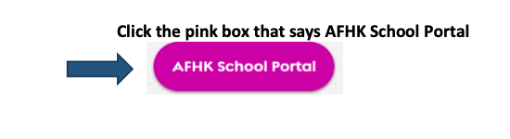
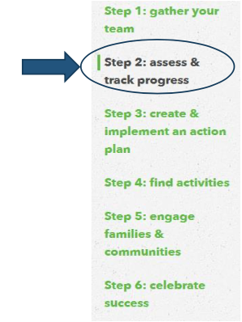

Step 2
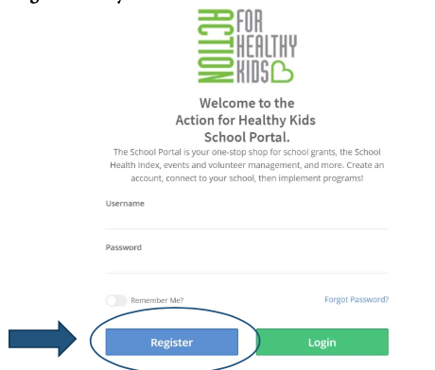
To Log into Action for Healthy Kids    Register with your GMSD Email
**Be sure to bookmark this page on your computer for easy return to this site.

Step 3
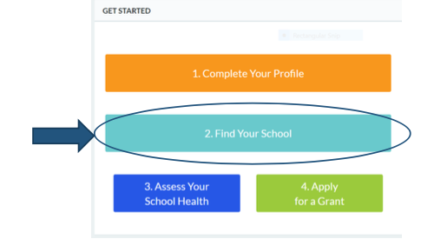
Once you are logged in it will take you to the AFHK School Portal. You will need to “find your school” by typing in 38138

Step 4
School Health Index- In the far left tab click “School Health Index”. This is where you will complete the assessment for your school. Once the tab opens up, you will “Start a New Health Index”, Find your School, and Click “GO”. You will then complete all of the questions through the 8 tabs at the top. Once the questions are completed you will submit your SHI. AFHK will generate a report.
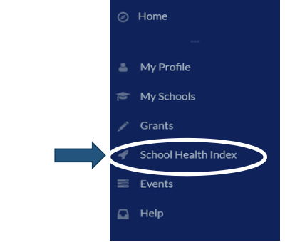

Step 5
After you receive your generated report and bar graph, you will complete your Action Plan with your Healthy School Team. The Action Plan template is attached.
Action Plan Requirements:

Goal 1: Childhood Obesity
- Write a goal to address/ reduce childhood obesity in your school.

Goal 2: Choose your own School Goal
- Write a goal pertaining to the Coordinated School Health’s 8 Components of Health. Use your Action Plan Report to determine your goal 2 based on need in your school.
Goal 3: Choose your own School Goal
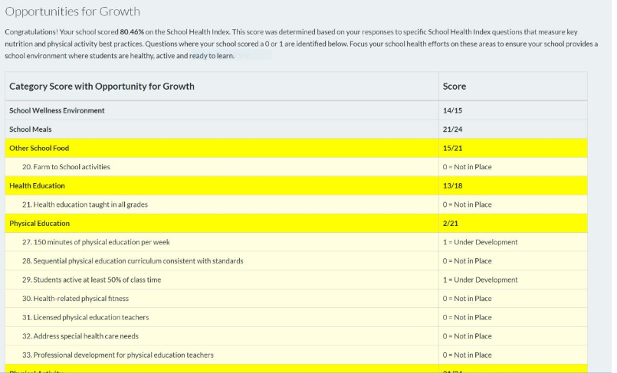
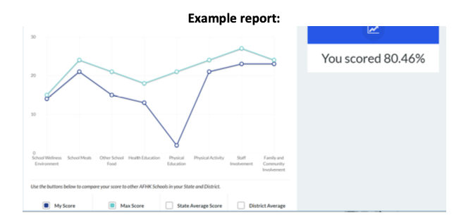
- Write a goal pertaining to the Coordinated School Health’s 8 Components of Health. Use your Action Plan Report to determine your goal 3 based on need in your school.

Healthy School Team Meeting Agenda

School:
Date:

Members Present:

Members not in attendance:

Facilitator:
Time Keeper:
Recorder:

Team Goals – Create a brief meeting goal related to student health and wellness with your Healthy School Team Members to determine the focus of the meeting.

What | Process/Guiding Questions | Time
Opening  Introductions Announcements | Review the meeting norms and provide quick objectives for the meeting.
Business | List out each topic that must be discussed, who will be leading the topic, and how long it will take to cover the topic.  Examples:  - Fill in Component Tracker  - Update In-Kind Donations Sheet (Share on One Note for team to update throughout the year)  - Action Items from last meeting  - Review Action Plan for next steps  - Start implementation of Goal 1 in Action Plan
Process Check/  Wrap Up | Summarize your action items, set a date for your next meeting and evaluate how this meeting went or what needs to improve.  - Next Meeting Date:  - Meeting evaluation  - What went well?  - What do we need to improve upon for next time?
Action Items | List out Action Items and put the person’s name responsible for the action item next to each.
Support Needed | Determine support needed to implement Action Items successfully.

Due to Andrew Martin by Oct 7th, March 10th, and May 12th Andrew.martin@gmsdk12.org

HST Position | Name | Email
HST Leader
Principal/Assistant Principal
School Counselor
School Nurse
Nutrition Manager
Special Education Teacher
PE/Health Teacher (If not Leader)
Parent
Student
Community Partner
General Education Teacher
School Resource Officer
Healthy School Team List 20__-20__
School:______________________

Due to Andrew Martin by September 16th
Andrew.martin@gmsdk12.org

