Athletic Emergency Action Plan
HOUSTON HIGH SCHOOL

Table of Contents

Overview of Emergency Action Plans (EAPs)
- Introduction
- Components of an EAP
- Emergency Personnel
- Emergency Communication
- Emergency Equipment
- Medical Transportation
- Non-medical Transportation

Emergency Contact List

Accident/Injury Contact Phone Tree

Sample Campus Map

Campus Map with AED Locations Marked

Venue Information Chart

Staff Medical Certification Requirements

Verification of Training Using the Emergency Action Plan

Introduction

Emergency situations may arise at any time during athletic events. Expedient action must be taken to provide the best possible care to the sport participant. The development and implementation of an emergency action plan will help ensure that the best care will be provided.

As emergencies may occur at any time and during any activity, all school activities workers must be prepared. Athletic organizations have a duty to develop an emergency plan that may be implemented immediately when necessary and provide appropriate standards of emergency care to all sports participants. As athletic injuries may occur at any time and during any activity, the sports medicine team must be prepared. This preparation involves formulation of an emergency plan, proper coverage of events, maintenance of appropriate emergency equipment and supplies, utilization of appropriate emergency medical personnel, and continuing education in emergency medicine and planning. Hopefully, through careful pre-participation physical screenings, adequate medical coverage, safe practice and training techniques and other safety avenues, some potential emergencies may be averted. However, accidents and injuries are inherent with sports participation, and proper preparation on the part of the sports medicine team should enable each emergency to be managed appropriately.

Components of an Emergency Plan
1. Emergency Personnel
2. Emergency Communication
3. Emergency Equipment
4. Roles of First Responder
5. Venue Directions with a Map
6. Emergency Action Plan Checklist for Non-Medical Emergencies

Emergency Personnel

The first responder in an emergency during an athletic practice or competition is typically a member of the sports medicine staff, such as a certified athletic trainer. However, the first responder may also be a coach or another member of the school personnel. Certification in cardiopulmonary resuscitation (CPR), first aid, automated external defibrillator (AED), prevention of disease transmission, and emergency plan review is required for all athletics personnel associated with practices, competitions, skills instructions, and strength and conditioning [also including: athletic director, school nurse, certified athletic trainer, all coaches, etc.]. Copies of training certificates and/or cards are maintained in the athletic training facility and/or with the athletic director.

The emergency team may consist of physicians, emergency medical technicians, certified athletic trainers, athletic training student, coaches, managers, and possibly bystanders. Roles of these individuals will vary depending on different factors such as team size, athletic venue, preference of the head athletic trainer, etc.

The four basic roles within the emergency team are:

Establish scene safety and immediate care of the athlete: | This should be provided by the most qualified individual on the medical team.
Activation of Emergency Medical Services: | This may be necessary in situations where emergency transportation is not already present at the sporting event. Time is the most critical factor, and this may be done by anyone on the team. However, the person chosen should be calm under pressure, communicates well, and is familiar with the location and address of the sporting event.
Equipment Retrieval: | May be done by anyone on the emergency team who is familiar with the types and locations of the specific equipment needed. Athletic training students, managers, and coaches may be good choices for this role.
Direction of EMS to the Scene: | One of the members of the team should oversee meeting the emergency medical personnel as they arrive at the site. This person should have keys to locked gates or doors.
Formation of an emergency team and implementation of specific roles are important. You should also assign more than one person to a role in case certain members are not present during a given situation.

Activation of Emergency Medical Services
- Call 9-1-1
- Provide Information
- name, address, telephone number of the caller
- nature of emergency (medical or non-medical*)
- number of athletes
- condition of athlete(s)
- first aid treatment initiated by the first responder
- specific directions as needed to locate the emergency scene (i.e. “use the south entrance to the stadium on Pomfret Street)
- other information requested by the dispatcher

Emergency Communication

Communication is a key to a quick, efficient emergency response. There should be a pre-established phone tree to ensure all relevant parties are notified. Access to a working telephone line or other device, either fixed or mobile, should be assured. There should also be back-up communication in effect in case there is a failure of the primary communication. At every athletic venue, home and away, it is important to know the location of a workable telephone.

Emergency Equipment

All necessary emergency equipment should be at the site and quickly accessible. Personnel should be familiar with function and operation of each type of emergency equipment. The equipment should be checked on a regular basis to ensure good condition and equipment use should be rehearsed by all emergency personnel. Creating an equipment inspection logbook is strongly recommended. Know how to properly care for and store all the equipment. You should choose a clean, dry, environmentally controlled area and it should be readily available when emergency situations arise.

This type of equipment could include spine boards and straps, automated external defibrillators (AEDs), AED pads, AED batteries, splinting equipment, helmet removal equipment and their batteries, etc.

Coaches should take note of the closest AED to their practice and game locations.

Medical Emergency Transportation

Emphasis is placed on having an ambulance on site at high-risk sporting events, such as football, gymnastics, track and field meets, etc. If an ambulance is on site, there should be a designated location with rapid access to the site and cleared route for entering/exiting the venue. If an ambulance is not on site, the medical personnel should be aware of average EMS response time for the athletic venue and distance from the venue to local hospitals.

Any emergency where there is impairment in loss of consciousness (LOC), airway, breathing, or circulation (ABCs) or there is a neurovascular compromise should be considered a “load and go” situation and emphasis placed on rapid evaluation, treatment, and proper transportation.

Conclusion

The importance of being properly prepared when athletic emergencies arise cannot be stressed enough. An athlete’s survival may hinge on the training and preparation of athletic healthcare providers. It is prudent to invest athletic department “ownership” in the emergency action plan by involving the athletic administration and sport coaches as well as sports medicine personnel. The emergency action plan should be reviewed at least once a year with all athletic personnel and local emergency response teams. Through development and implementation of the emergency plan HOUSTON HIGH SCHOOL helps ensure that the athlete will have the best care provided when an emergency does arise.

*The above Athletic Emergency Action Plan outlines the expectations and requirements for the LEA and every sports team that participates for on-site athletic activities at HOUSTON HIGH SCHOOL.

Approval and acceptance of the HOUSTON HIGH SCHOOL Emergency Plan for Athletics.

Approved by: ________________________________ Date: ____________________
School Principal

Approved by: ________________________________ Date: ____________________
School Athletic Director

Approved by: ________________________________ Date: _____________________
Head Athletic Trainer

HOUSTON HIGH SCHOOL

Important Contact List

Off Campus Contacts | Phone Number
Germantown Police Department | 901-757-7338
Germantown Fire Department | 901-754-1414  901-757-7268
Methodist Germantown | 901-516-6000
Tennessee Poison Control | 800-222-1222

On Campus Contacts | Phone Number
Athletic Trainer
SRO’s
Main Office
Principal
School Counselor Office
Athletic Director

Title | Name | Office | Cell
Athletic Trainer | Tripp Turner
Athletic Director | Marvis Davis
School Nurse | Celeste Waldrup
Principal | Hallie Ross

HOUSTON HGH SCHOOL
Contact Tree

Coach or First Responder at the Scene

Life Threatening Condition Non-Life-Threatening Condition

Call 9-1-1

Athletic Trainer
Tripp Turner:
Assistant Athletic Trainer
Haley Vance:

Athlete’s Parent or Guardian Athletic Director
Marvis Davis:

Principal
*Note: This is a basic plan. Please use Hallie Ross:
professional judgement when a player
is injured. Move down the chart if you
are unable to reach the appropriate
staff member.
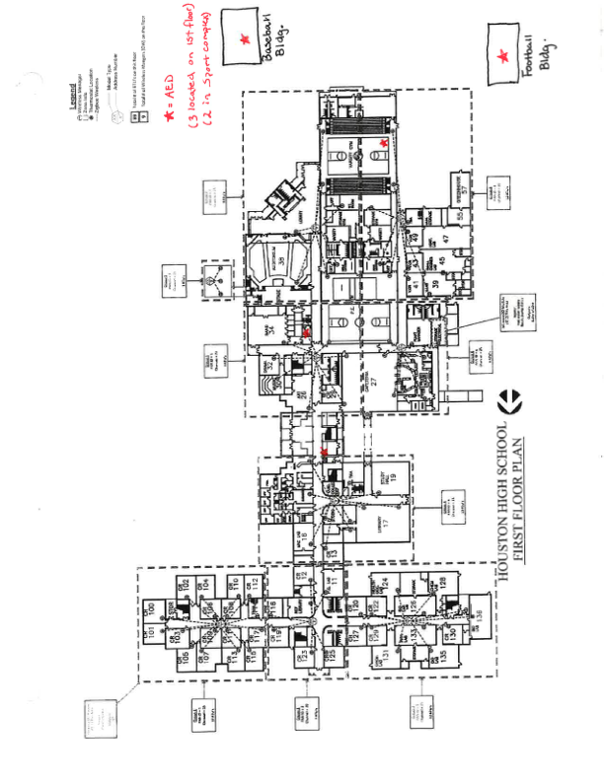
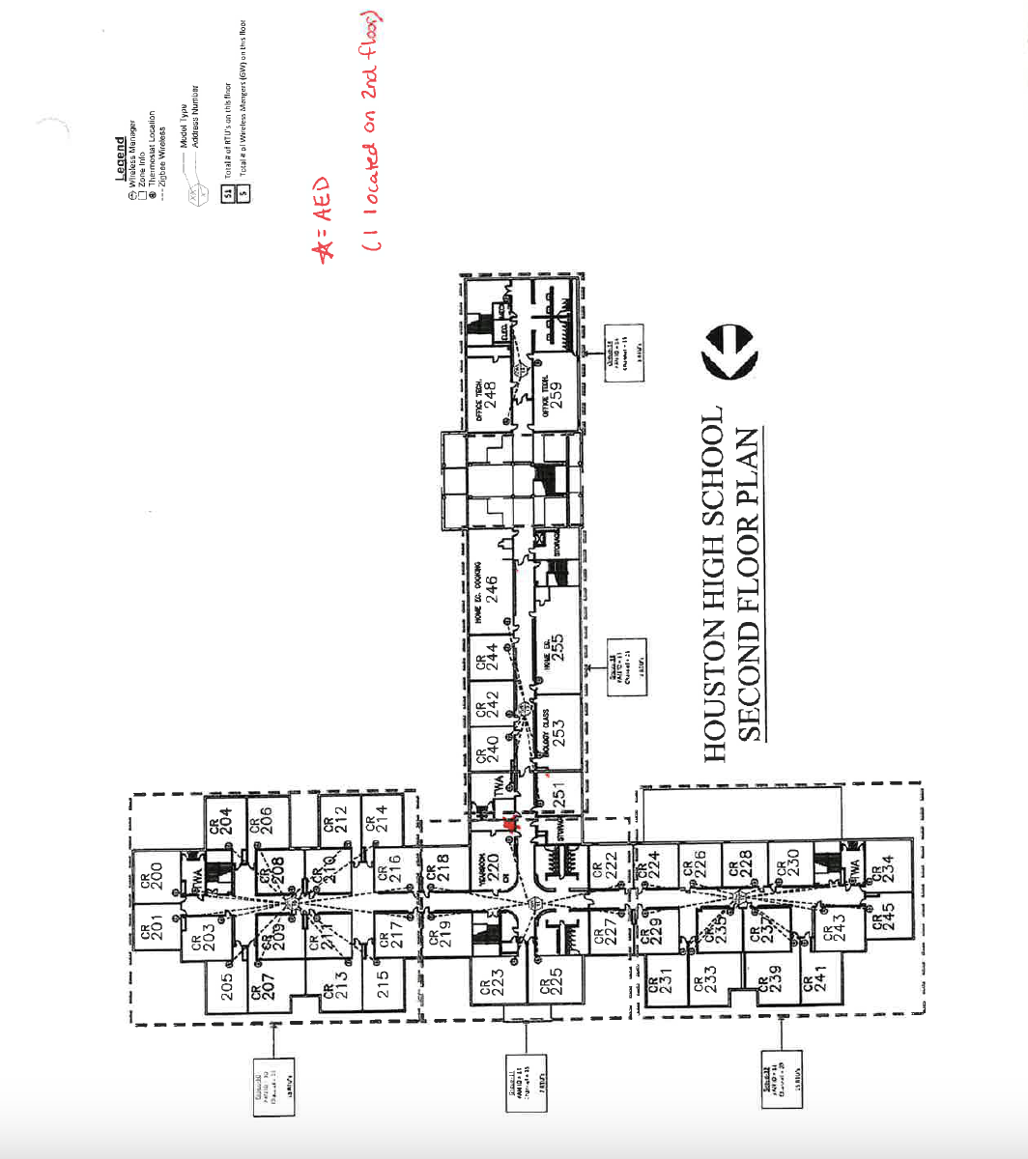

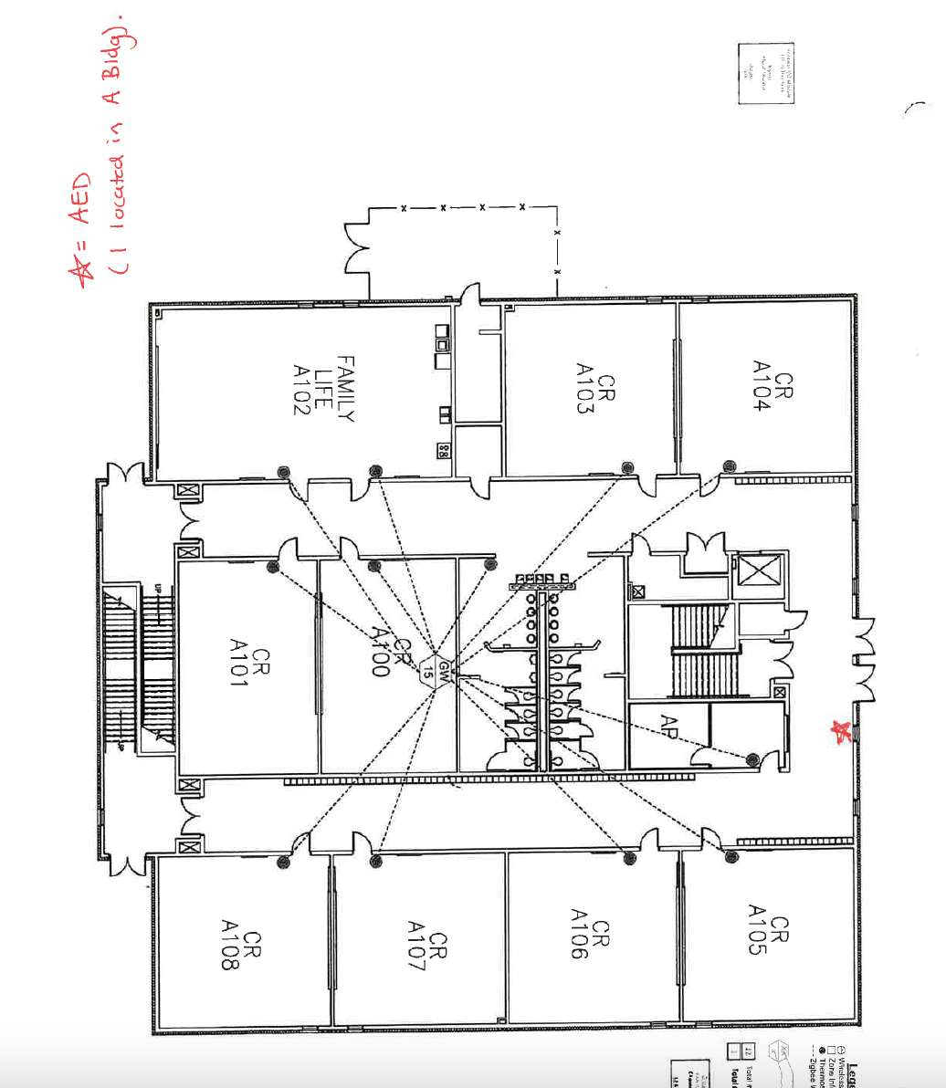
**AED located in EACH Sport Facility (Football, Baseball, Softball, and Soccer)
**3 portable AED units (2 for Athletic Trainers and 1 for Cross Country)
HOUSTON HIGH SCHOOL

9755 Wolf River Blvd. Germantown, TN 38139
Coordinates: 35.09468 N 89.73741 W

Campus Athletics Venue Information

Venue | EMS Route | Primary AED | Secondary AED
Varsity Gym | Main Entrance side of HHS; Enter by Auditorium | Basketball Court (near exit doors by Athletic Trainer Room) | Band Hallway (Near band room)
PE Gym | Main Entrance side of HHS; Enter by Main Lobby | Band Hallway (Near band room) | Basketball Court (Varsity Gym)
Football Field | Rear Entrance side of HHS; Enter by Football Facility | Football Facility (In Weight Room by trainer’s room) | A-Building 1st Floor (Near Main Entrance to A-Building)
Baseball Field | Main Entrance side of HHS; Enter next to Baseball Facility. | Baseball Facility (In Weight Room by Coach’s Office) | Softball Facility (In Weight Room near Main Entrance)
Softball Field | Main Entrance side of HHS; Enter next to Softball Facility. | Softball Facility (In Weight Room near Main Entrance). | Baseball Facility (In Weight Room near Coach’s Office).
*Soccer Field  (HMS Property) | Entrance on Wolf River Blvd. Take entry way to back of building by Soccer Field. | Concession Stand (Located next to bleachers on Soccer Facility) | Gym B (Located near doors in HMS Gym B).
*GYM A (HMS Property) | Entrance on intersection of Johnson Road and Wolf River Blvd; EMS will enter at New Main Entrance | Basketball Court in Gym A (Near doors by Main Entrance side of Gym) | Gym B (Located near doors in HMS Gym B)
*Gym B (HMS Property) | Entrance on Wolf River Blvd; EMS will take driveway to rear of building and enter via rear door of Gym B | Gym B (located near doors in HMS Gym B) | Hallway near old Main Entrance & Teacher’s Lounge)

*Soccer Field that HHS utilizes is located on premises of Houston Middle School. Address is 9400 Wolf River Blvd. Germantown, TN 38139

*Athletic Trainer and Assistant Athletic Trainer will have a portable AED unit at the athletic events they’re covering.

*Cross Country Head Coach will have a portable AED unit at the athletic events HHS is participating. (Events for Cross Country are held off campus)

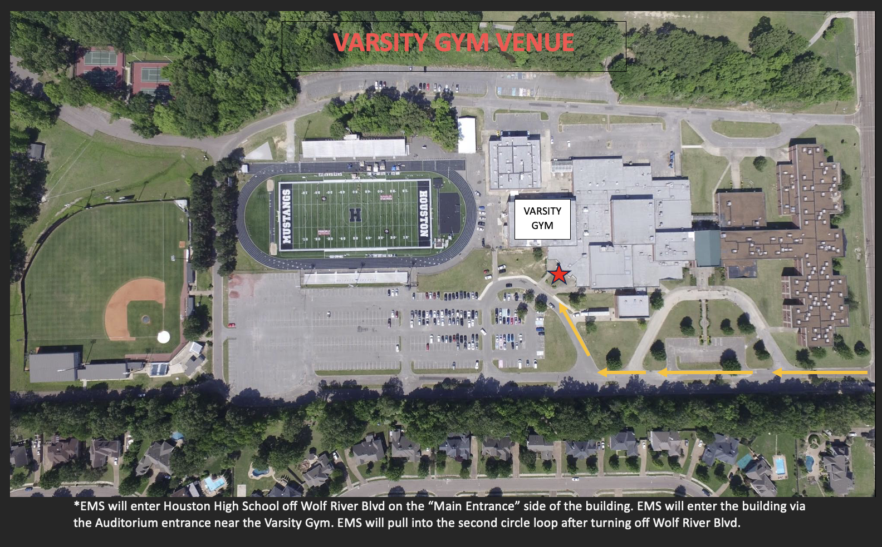
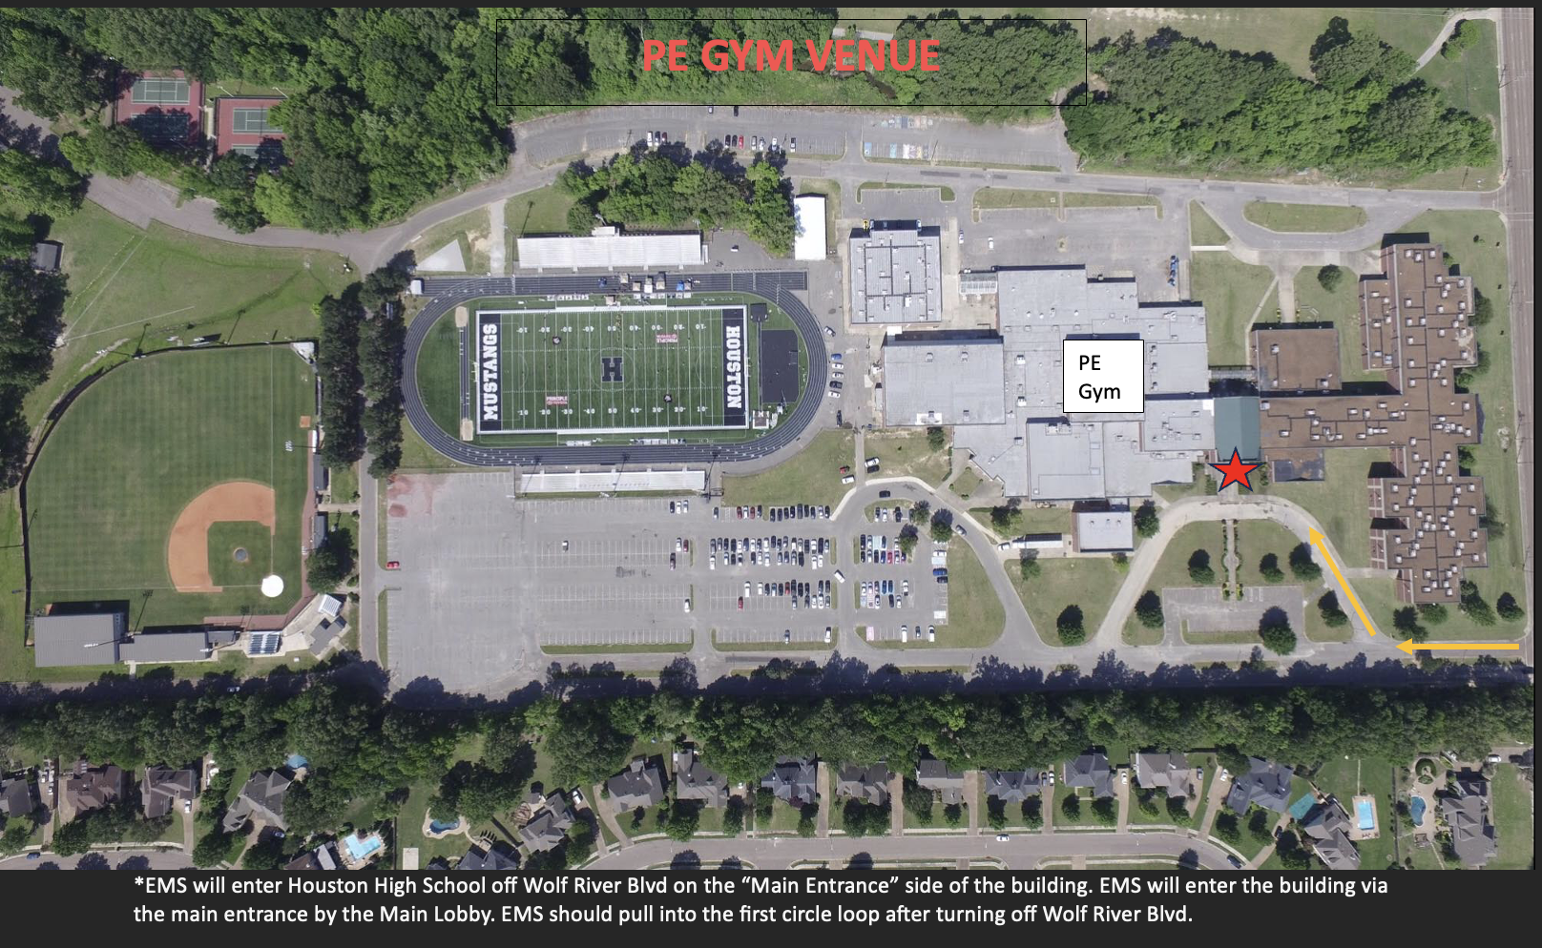
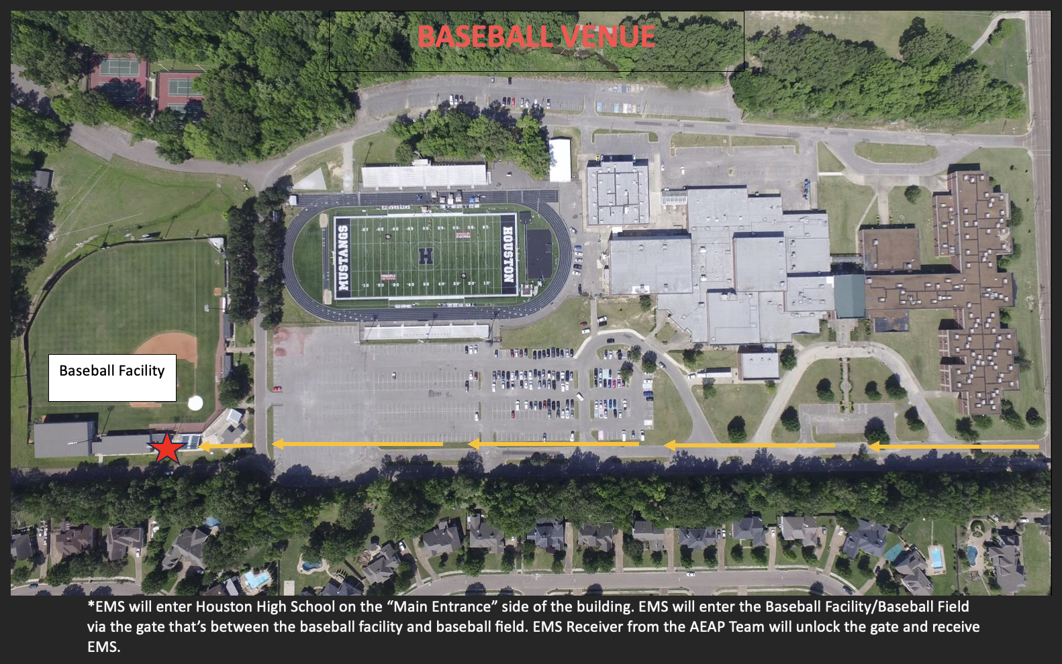
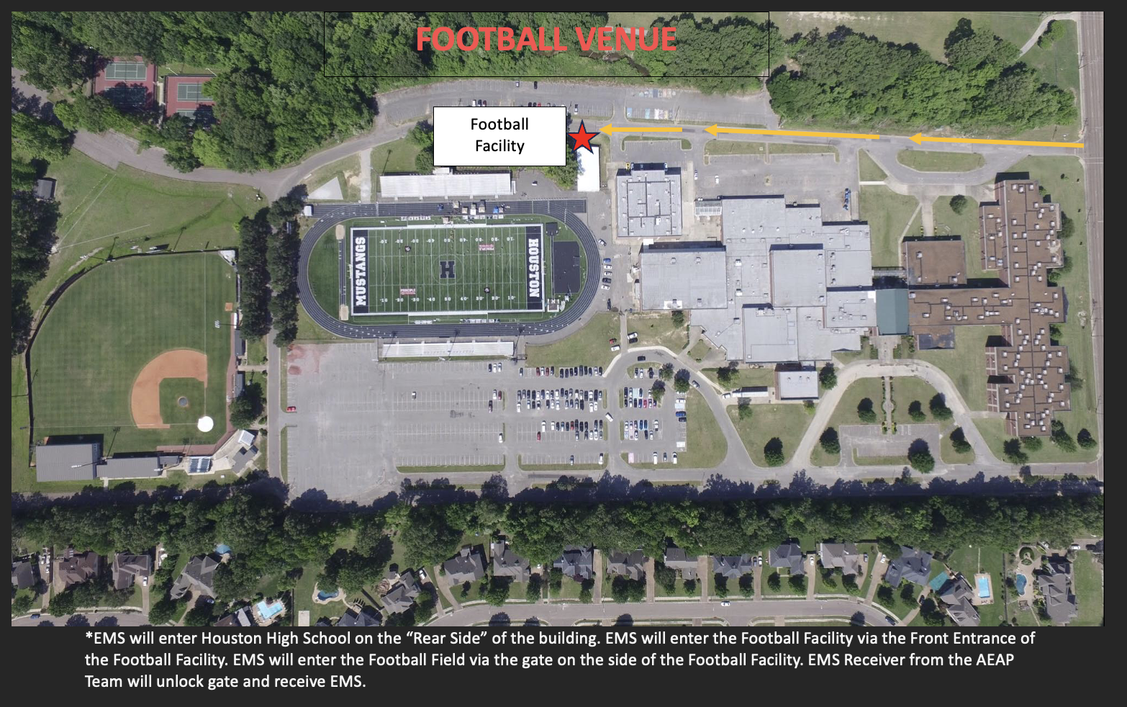
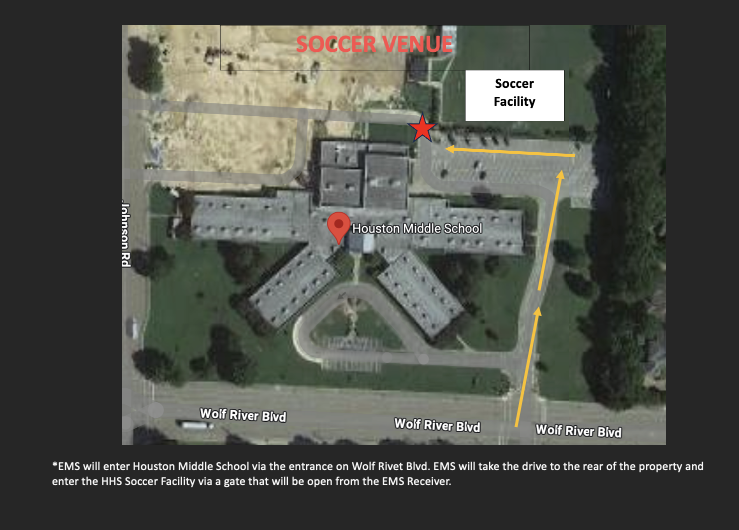
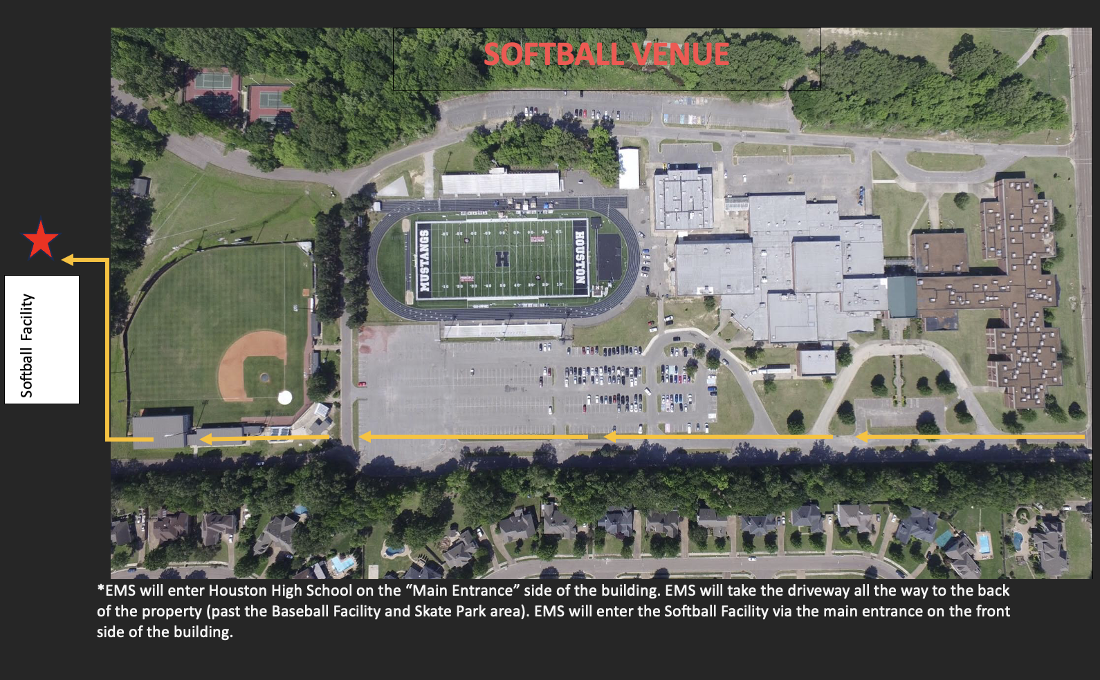
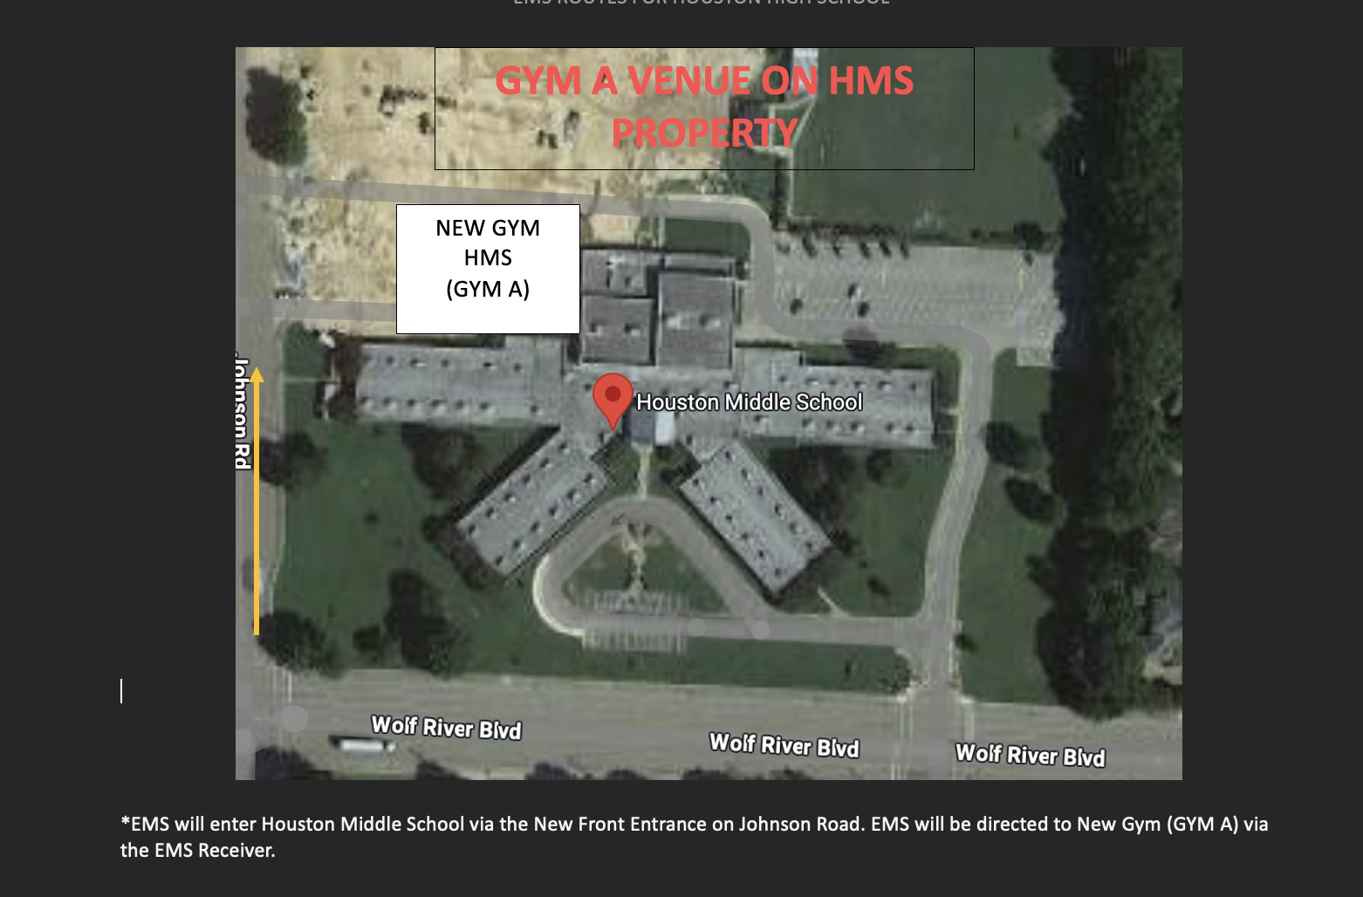
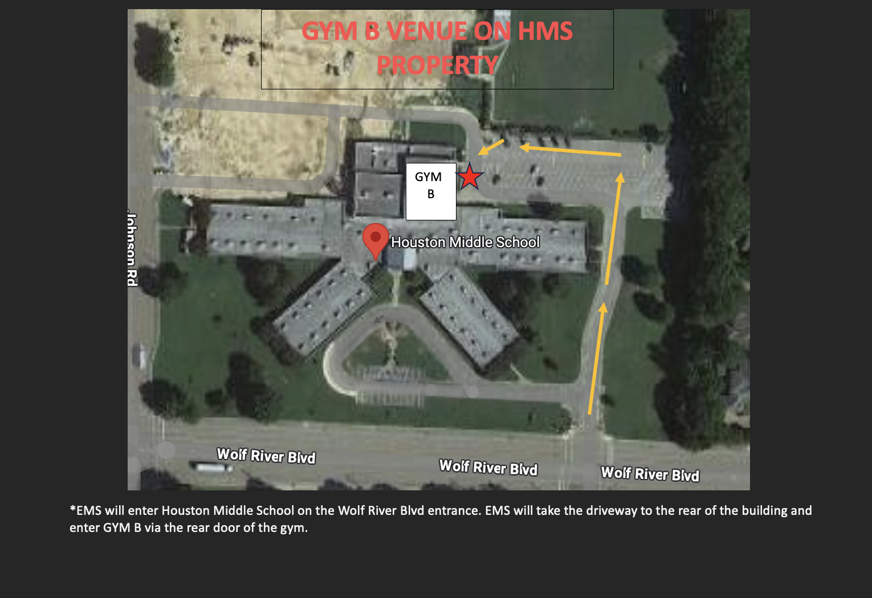
PROTOCOL FOR MEDICAL CERTIFICATION REQUIREMENTS

All athletics personnel associated with practices, competition, skills instruction, and strength and conditioning, including all head, assistant, and volunteer coaching staff, must have the following training:

- CPR & AED Certification for the First Responder
- First Aid Training for the First Responder
- Prevention of Disease Transmission: Blood Borne Pathogens
- Emergency Action Plan Annual Run Through
- Sudden Cardiac Arrest Training
- Heat-Illness Prevention Training
- Concussion Training

All updated copies of certificates/cards will be on file in the athletic director’s office.

Sport | Staff Member | CPR/AED Good Until | First-Aid Good Until

HOUSTON HIGH SCHOOL
AEAP Team
*Team is specific to each individual sport for the LEA

Role | Assigned Staff Member | Duty
Rescuer 1  (CPR Trained Personnel) |  | Assess safety of scene, victim and situation, directs someone to call 9-1-1 and requests AED, initiate emergency response team, alert to victim’s location, assure victim is on a firm surface, initiate CPR
Rescuer 2  (AED) |  | Brings AED to location of victim, leaving the AED cabinet door open so it will alarm, and others will know it has been retrieved.
Rescuer 3  (CPR Trained Personnel) |  | Assist with CPR
Rescuer 4  (Crowd Control) |  | Keep others from getting in the way, traffic control of the area, verify no one is recording with a cell phone, etc.
Rescuer 5  (Timekeeper) |  | Document event on proper paperwork.
Rescuer 6  (Student Info Gatherer) |  | Obtain student emergency information and contact parent/guardian.
Rescuer 7  (EMS Receiver) |  | Await arrival of EMS and direct them to the scene
*This drill must be practiced annually and communicated to CSH & Athletic Director
*If your coaching staff does not consist of enough members to fill out the roles for the above AEAP Team, you will defer to the Emergency Contact Tree and complete the following as the First Responder:

- Call 9-1-1 (If emergency is present)
- Provide CPR/AED and First-Aid care.
- Have students from your team aid with retrieving AED (if needed) and receiving EMS.

Emergency Action Plan Run Through

All personnel associated with athletics should be familiar with all relevant venue emergency action plans. Familiarization includes knowing one’s specific role during an emergency, knowledge of emergency equipment, and how to appropriately activate the emergency action plan.

Each person who will be working with the school’s athletic programs should be given a copy of the emergency action plan annually and sign an agreement that they have read and understand the document.

Additionally, each team before the start and throughout the season should run through scenarios to increase the comfort level and efficiency of the emergency action plan. This team should also include the local ambulance services and the fire department. Ensure that all team members are on the same page with athlete care and transport protocols (i.e. helmet removal for equipment-intensive sports such as football and lacrosse or “cool first, transport second” policies for exertional heat illnesses). Run-throughs should also be taken into consideration where ambulance access would take place to determine if any gates or cars would block the entrance during practice/game times and where any keys or relevant equipment will be located.

VERIFICATION OF ACKNOWLEDGEMENT OF TRAINING ON THE EMERGENCY ACTION PLAN

Each coach or volunteer in every sport providing instruction, assistance, or supervision in an athletic activity for the student athletes at HOUSTON HIGH SCHOOL must sign this form certifying that the coach or volunteer has completed the training on the emergency action plan. The training must be completed annually.

I hereby verify by signing below that I have completed the training on the emergency action plan.

Name | Title or Position | Date | Signature

THIS FORM IS TO BE KEPT ON FILE IN THE ATHLETIC TRAINING ROOM AND PRESENTED FOR REVIEW UPON REQUEST.

