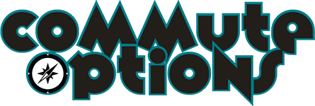
Physical Education Lesson Plans 4th-5th Grade
30 minute classes

Welcome!
This is a step-by-step user guide for starting a Pedestrian and Bicycle Safety unit in your Physical Education program. Specifically geared towards 4th and 5th grade students, this Unit focuses on students knowing how to use the transportation system safely; all in a fun and physically active way.

The Pedestrian and Bike Safety Unit consists of 6 thirty minute lessons that can be adapted to your specific school and area. This is a cumulative curriculum, each lesson builds upon the last. Students move to the next activity, when they shown competency in the current one. Starting inside with the basics and moving outside to practice, each lesson emphasizes awareness, good decision making and personal responsibility.

This step-by-step guide outlines each lesson with the goal for that day, the materials and setup needed, the time spent on each activity and evaluations to be done before moving on to the next lesson. Each lesson can be adapted to your school and the area, keeping the content relevant to your students and where they will be walking/biking.

4th/5th Grade Lesson Summary and Learning Objectives

Lesson # | Lesson Summary | Learning Objectives
Lesson 1 | Pedestrian Safety | Students learn and practice the basic rules of being safe pedestrians.
Lesson 2 | Helmet Fitting and ABC Quick Check | Students fit helmets and learn to check their bike before riding.
Lesson 3 | Bicycle Handling | Students learn and demonstrate proper stopping and starting technique, shoulder checking, and hand signals.
Lesson 4 | Intersection Game and Right of Way | Students learn about in-depth right of way rules for 2-way, 4-way and roundabout intersections. Students practice this knowledge with an intersection game.
Lesson 5 | Intersection Game Outside | Students practice right of way rules on bikes with an intersection game. Students learn the proper way to turn left and to turn right.
Lesson 6 | Hazards and Neighborhood Ride | Students identify cycling hazards and how to avoid them. Students use their new skills for a neighborhood ride.

Purpose: To provide students with the knowledge and skills to use the roads safely as pedestrians and when riding bikes.

Benchmarks: To be determined

Class Expectation: Students are respectful and taking the class seriously. Students are listening to the teach and following instructions.

Evaluations: To be used to help identify when the class can move forward.
Lesson 1: Students can demonstrate an understanding of the steps to crossing the road safely. Students can repeat steps verbally and physically as individuals.
Lesson 2: Students can demonstrate the 2 finger check on their helmets as individuals. Students can identify the parts on their bikes necessary for the ABC Quick check and can understand when their bike is safe to ride.
Lesson 3: Students can safely ride their bike while verbally and/or physically demonstrating their signals.
Lesson 4: Students are able to safely turn on the course. Students are able to combine bike handling techniques, use of signals and an understanding of the intersections.
Lesson 5: Students are able to practice their bike safety skills on the course with minimal interference. Students can make decisions as individuals while practicing bike skills.
Lesson 6: Students are able to display an understanding of how to make safe decisions when riding on the roadways.

Lesson 1 (Pedestrian Safety):

Objectives:
1. Demonstrate and identify pedestrian crosswalk/sidewalk safety skills
2. Be able to define roadway vocabulary words

Materials:
5-10 cones

Intro Game (2 minutes)
Have each student stand at a cone in a circle, run across the circle to another cone when something I say is true for you.
- Find another cone if you like to play outside.
- Find another cone if you like to ride your bike.
- Find another cone if you know that exercise is good for your body
- Etc.

Define pedestrian (2 min)
“A person who is using their feet, and is outside using the roadway”

How can we stay safe when we are walking and playing outside? (2 mins)

Watch Pedestrian Safety Video (3 mins)
https://vimeo.com/50648558

Review steps to crossing the street (5 minutes)
1. STOP at the curb
2. Put one foot on the crosswalk
3. Look Left, Right then Left again
4. Wait for the vehicles to stop completely
5. Make eye contact with the driver
6. Continue looking left and right as you cross
7. Wave, Smile and say Thank You!

Go outside and practice crossing (15 mins)
Have every student cross in groups of three, following all the steps
Cross again one at a time, make sure to stop and look LRL!

Can’t go outside? Set up an indoor crosswalk.
Use large cones to show the edge of the curb. Use lines on the gym floor as the roadways.

Evaluate: Before moving forward with the next lesson, evaluate whether or not students can demonstrate an understanding of the steps to crossing the road safely; Students can repeat steps verbally and physically as individuals.

Lesson 2 (ABC Quick Check and Helmets):

Objectives:
1. Understand the importance of and how to properly perform a safety check on a bicycle
2. Understand the importance of and how to properly fit a helmet
3. Learn the four legal hand signals used in Oregon and when to use them

Materials:
If available, have helmets for students to borrow if they are not able to bring their own
Bring 1 bicycle into the gym

Review: What did we learn yesterday (2 mins)
- How to cross safely!

Play roadway vocabulary game (5 minutes)

Bicycle = on back doing bicycle crunches
Pedestrian = Walking around the gym
Vehicle = Start running laps around the gym
Crosswalk = Run to the red line and look left, right, left. Then voices off!
Intersection = line up at one of these cones (set out 4 cones). Call out the different hand signals. Students do the hand signals and use their voices. First time you call intersection you will have to explain the hand signals. Have the students follow along as you explain them.

Helmet Fitting 101 (5 mins)
- Watch video https://vimeo.com/93441701
- Fit helmets and have students put their names on them with masking tape and sharpie
- Store helmets in bags

ABC Quick Check (10 mins)
- Watch video https://vimeo.com/91370464 (finish adjusting helmets)
- Review how to do ABC Quick Check
- Relay race or stretching exercise (8 mins)
3 groups and 3 bikes
Each group sends a person down, teacher asks student to show them one of the ABCQ components, if they get it right they can run back and send another student, if they get it wrong they have to answer a different ABC Quick check question until they get it right.

Evaluate: Before moving forward with the next lesson, evaluate whether or not students can demonstrate the 2 finger check on their helmets as individuals; Students can identify the parts on their bikes necessary for the ABC Quick check and can understand when their bike is safe to ride.

Lesson 3 (Bike Handling):

Objectives:
1. Gain confidence using hand signals and shoulder checking while riding bicycle

Materials:
Bike pump
Extra helmets available for anyone who forgot their helmet
3 cones for ABC Quick Check lines
Additional cones to outline riding courses

Pass out helmets

Review: What did we learn yesterday? (2 mins)
- How to cross safely
- Hand signals
- ABC Quick Check

Introduce Class Oath (5 minutes)
1. Have fun!
2. Always wear a helmet
3. Be respectful (to care for…)
4. No tricks
5. Ride when it’s time
Ask students to agree to the oath and to the determined consequences. If students cannot obey the oath and it is not safe to have them ride with the class, determine if they are allowed to remain in the bike safety unit.

Introduce Group Riding Rules (3 min)
1. Use a Ghost Space (students ride with a bike space distance between each other)
2. Ride in a straight and single-file line
3. No passing (unless someone has gotten off their bike for a personal or mechanical issue)

Personal Safety Check Stretch (2 mins)
- Reach down to your toes, and check your shoe laces
- Come up half way and check your pant legs
- Twist to one side and check your waist, twist to the other side
- Reach up high and then check your helmet

Gather bikes and line students up single file behind cones (10 minutes)
Do ABC Quick Check
Go over riding rules again

Split into two separate riding groups and demonstrate the following: (5 minutes)
(Use cones to create large circles to ride around)
- Power pedal position (starting)
- Stopping (pull both brake levers at same time)
- Shoulder check (why take hand off handlebar?)
- Hand signals (Left, Right, Stopping)

Line students up and go back to class (3 minutes)
Helmets to remain on students’ heads until they are back in the classroom to avoid damaging or losing helmets.

Evaluate: Before moving forward with the next lesson, evaluate whether or not students can safely ride their bike while verbally and/or physically demonstrating their signals.

Lesson 4 (Right of Way and Intersection Game):
Objectives:
- Students are able to safely use a four-way intersection, a three-way intersection and stop signs.

- Materials
  - 6 cones
  - Masking tape
  - Projector
- Advance Preparation
  - Setup cones following the diagram (one at each stop sign)
  - Use 4-6in strips of tape to delineate the two lanes of traffic
  - Video loaded and connected to projector
  - Draw out the intersection game you have set up on a whiteboard or a large piece of paper.
- Vocabulary
  - Right of Way: who gets to go and who has to wait
  - Vehicles: people riding bikes, driving cars and trucks
  - Points of Conflict: when you cross over another lane of traffic
  - Take the lane: leaving the right side of the road or the bike lane
  - Shoulder Check:
  - Signals:
  - Eye Contact:
  - Stop Sign
  - Lanes of Traffic
- Activities
  - Review: What did we learn yesterday (2 mins)
- Bicycle hand signals
- ABCQ Check
- Introduce Right-of-Way (4 way stop) (5 mins) https://vimeo.com/105087193
- Play Intersection Game!

Set Up:
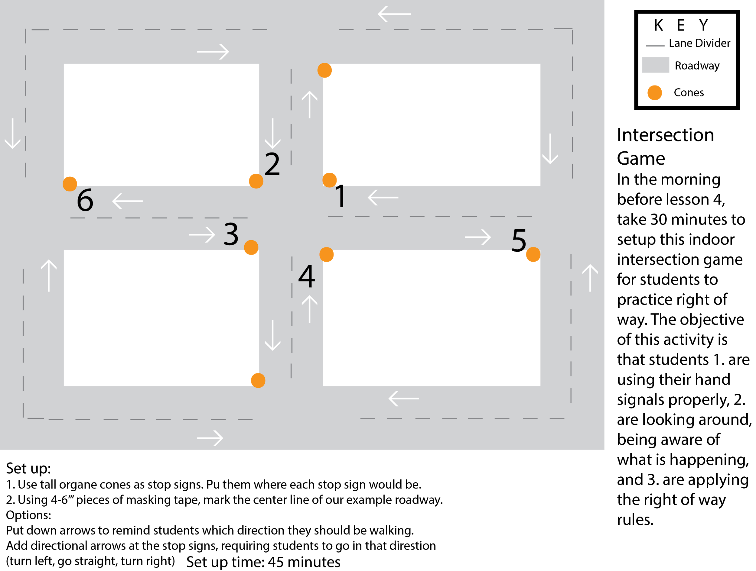

Class Time:
- Review: what did we learn last class?
  - Hand Signals
  - ABCQuick Check
- Introduce Right of Way
  - Ask the class what Right of Way means
  - Watch Right of Way Video
    - https://vimeo.com/105087193
    - During the video pause and talk about each rule
    - Tips: We use the rules in order, and it doesn’t matter what vehicle you are using.
  - Review the steps by choosing two volunteers to demonstrate each step in the intersection you set up before class
  - Using your drawing of the intersection, show the class what they will be doing today.
    - Talk about stop signs and not stop signs
    - Penalty for running a stop sign: 5 push ups
    - Penalty for passing another student: 5 sit ups
    - Review straight goes first, left goes last even if there are no stop signs

- Line up the students shoulder to shoulder, count out six at a time and send them to line up at their spot. 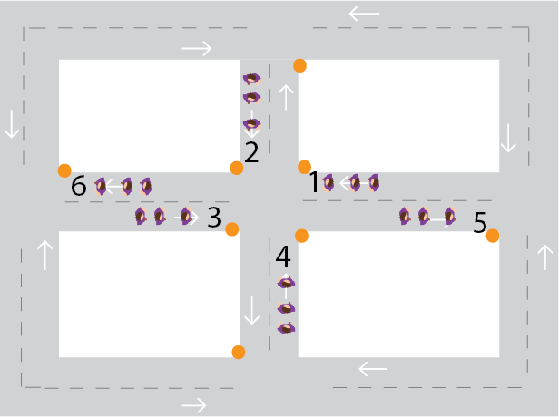

- Play Time! Let them play the game for a little bit. Be mobile, watching the 4 way and calling out students who run stop signs or pass each other.
- Use flat tire to get their attention again and correct any common mistakes. Take a moment to show that if you are both going straight you can go at the same time. If you are both turning right you can go at the same time.

Evaluate: Students are able to safely turn on the course. Students are able to combine bike handling techniques, use of signals and an understanding of the intersections.
  - Did the students apply right of way during the game?
  - Did students stop at the stop signs?
  - Did students take the game seriously?
  - Did the students ask relevant questions?
  - Did the students use their hand signals?

Lesson 5 (Intersection Game Outside):
- Objectives:
- 1. Understand the applications of right of way rules in the “real world”

- Materials
  - Large space (a field or unused parking lot)
    - A way to put lines on the ground (coordinate with maintenance department to paint on the field, or use sidewalk chalk on a parking lot)
  - 10 large orange cones
  - 6 small orange cones
  - 5 tall yellow cones
  - 20 flat cones (color doesn’t matter)
- Advance Preparation
  - Review intersection game video: https://vimeo.com/105209464
  - Draw out the intersection game on a large piece of paper or whiteboard
  - Follow set up the intersection game (30-45 minutes)
- Vocabulary
  - Intersection
  - Roundabout
  - Yield
- Activities
  - Review what we learned last class?
    - Rules of Right of way
    - Hand signals
    - ABCQuick Check
  - Watch Roundabout Right of Way Videos
  - Use your drawing of the game to explain how it works
  - Line them up in a single file line to head outside
  - Play the Intersection Game
  - Go back inside with 5-7 minutes left in class
- Teacher Reflection/Class Evaluation
  - Did the students apply the rules of right of way?
  - Did they stop at yield signs?
  - Did they yield at yield signs?
  - Did they use their hand signals?
  - Did they take it seriously?
Set up:

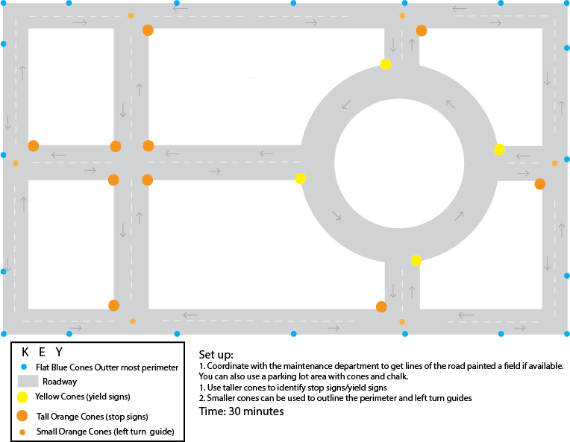
- Two weeks before this class, select where you would like to do this activity: on a field, in a parking lot, whatever large space you have access to that is safe for students to practice.
  - If you are using a field, coordinate with the maintenance department to paint the roads onto the field.
- Use large orange cones as stops signs, large yellow cones as yield signs and small flat cones as left turning guides and perimeter cones.

Class Time:
  - Review what we learned last class?
    - Rules of Right of way
    - Hand signals
    - ABCQuick Check
  - Watch Roundabout Right of Way Videos
    - Pedestrian: https://vimeo.com/70227389
    - Vehicle: https://vimeo.com/59621283
    - Review steps for each option after each video
  - Use your drawing of the game to explain how it works
  - Line them up in a single file line to head outside
    - OPTION: your class may be ready to use the intersection on their bikes, if so make sure they have their helmets on, shoes tied and bikes parked near the intersection game.
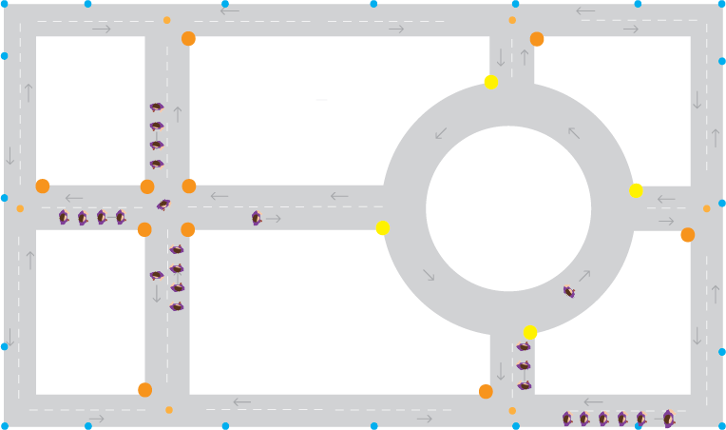
  - Outside have the students follow you in a single file line around the outside roadway. Count off 5 at a time to enter at various points in the intersection
    - NOTE: this is the same with bikes, but you must do the ABCQuick check first.

  - Students can start the game as soon as they enter the intersection. Once all the students have been “dropped off” you can be mobile and watch how the students are doing.
    - OPTION: take a few student volunteers to get be neighborhood watch, and politely call out students who run stop signs or pass each other.

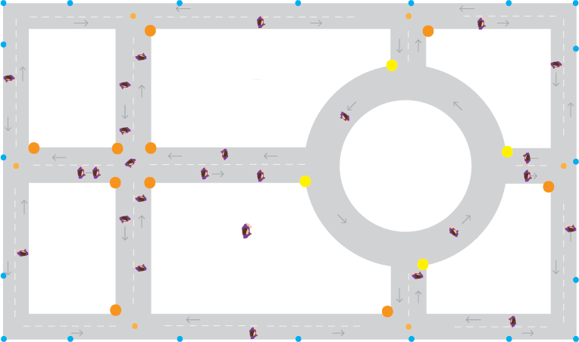

  - After a bit, use flat tire to get everyone’s attention and correct common mistakes.
  - Go back inside with 5-7 minutes left in class
    - NOTE: Take more time to go back inside if students are on bikes
Evaluate: Students are able to practice their bike safety skills on the course with minimal interference. Students can make decisions as individuals while practicing bike skills.

Lesson 6
Options: repeat lesson but on bicycles or take students for a neighborhood ride.
If repeating lesson 5, refer to lesson 5 for instructions.
- Objectives
  - Students show understanding and application of rules of right of way
  - Students show comprehensive understanding of how the transportation works and why it is important for them to pay attention and make good decisions.
- Materials
  - Off campus ride requires permission slips be signed by parents/guardians (like a field trip)
  - Printed route maps
  - Adult volunteers
  - Bicycles
  - Helmets
- Advance Preparation
  - The day before remind students to bring bikes and helmets (park bikes in same location)
  - Recruit volunteers
  - Plan route (short, right turns, few stop signs)
- Vocabulary
  - Ghost Space
  - Single file lines
- Activities
  - Review what everyone has learned in Bike Safety
    - Rules of Right of Way
    - ABCQuick Check
    - Hand Signals
    - Shoulder Checks
    - Group Riding Rules
    - Safe Pedestrian
  - Talk about riding on the road: shoulder check around parked cars, stop at stop signs and follow group riding rules.
  - Do personal Safety Check: shoes, pants, helmets
  - Pass out orange safety vests if you have them
  - Line out and head out!
  - Do ABCQuick check and shake down ride
  - Off you go!
  - During the ride, regroup several times. Do not send students through an intersection that is not being watched by an adult volunteer or yourself. What works well is having a strong student leader at the front. At a stop sign, send them ahead with an identified stopping point within eyesight of the stop sign. Help the rest of the class get through the stop sign. You can also leave an adult volunteer at the stop sign and move ahead. Your volunteer should them ride up ahead to the next stop sign.
Evaluate: Students are able to display an understanding of how to make safe decisions when riding on the roadways.
  - Did the students apply the rules of right of way?
  - Did they use their hand signals?
  - Did they stop at stop signs?

